
6
Tools and Tips for Decision-Making
and Reaching Agreement
Module

Here are a few examples of ways to help reach agreements and make decisions within your CLIP. For more tools see Senge et al (1994). Using various decision-making tools and being clear on decision making processes can go a long way to reducing tensions in a group.

Defining a Topic
It helps to define a topic by clarifying what it is and what it is not. Make two columns on a flipchart page. Label one “Is” and the other “Is not”. As questions that help clarify the topic. For example:
• Identify: What is the decision? What is not part of the decision we are making?
• Influence: Who is affected? Who is not affected?
• Impact: Where is the decision likely to have an impact? Where is not the decision likely to have an impact?
• Timing: When is it an issue? When is it not an issue?

Checkpoint
Ask each person periodically to briefly give his/her opinion. This helps to keep everyone involved. It can be used at any stage in the inquiry.

Brainstorming
At various times you will want to generate many ideas. Brainstorming is a useful technique. Brainstorming involves asking people to generate ideas about a topic and recording them without making judgments about whether they are feasible, acceptable, or applicable. Sometimes just seeing ideas in juxtaposition helps participants create new possibilities from ideas that would not work on their own. After all ideas are given, participants can start looking at whether they want to employ them in their situation.

Brainstorming using a Task Worksheet
Typically, the CLIP uses brainstorming techniques to bring out the issues and concerns. The Task Worksheet is a simple approach for getting ideas out about handling the tasks in the inquiry. First the Recorder writes down all the tasks that participants envision needing to accomplish in the inquiry. Then the participants determine the chronological order and the Recorder lists the tasks on the Action Plan Worksheet in the order in which they should be accomplished (some will occur simultaneously). Participants work together to determine who will be responsible for each task, the end/start date of the task, resources needed to accomplish the task, and expected outcomes. As the participants make these decisions, the Recorder fills in the worksheet.
Task Worksheet
Tasks  (Chronological Order) | Person Responsible | Start/End | Resources | Expected Outcomes

Brainstorming Using A Fishbone Tool
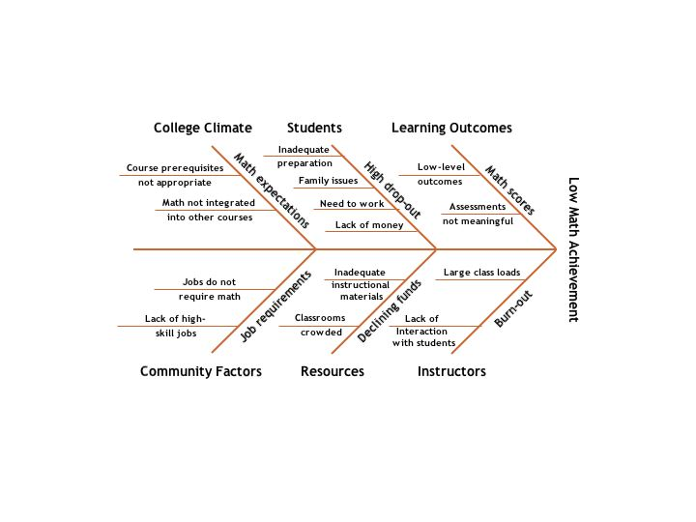
The Fishbone Diagram is a brainstorming tool to help a group see possible factors contributing to a problem. The fishbone diagram pictorially helps identify possible causes and effects. After using it, the group needs to investigate to determine actual causes and effects.

Brainstorming Using a Force-Field Analysis
A Force-Field Analysis uses brainstorming to come up with a list of forces that dampen change and those that reinforce change. The group then ranks the forces for and against change. Create two columns on a flipchart page. Label one as Facilitating Forces and one as Restraining Forces.

Mountain Hike
Draw a basic mountain shape and trail similar to the one in the figure here. In the “cloud” near the top, write in your goal.
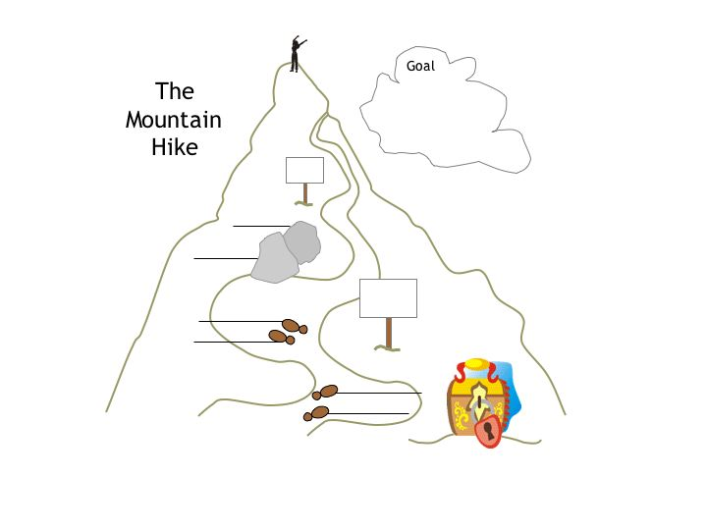
Now go back to the bottom of the mountain and identify the steps you’ll need to take to reach the goal. Write them on the lines next to the footsteps. Identify the attitudes, events, or conditions that may block reaching the goal. Write them on the lines next to the boulders along the path. Identify the resources you will need. Write them on the bag near the bottom of the trail. On the signposts, write milestones along the way that will help identify progress.

Reflective Ranking
The Reflective Ranking technique can be used with several other tools to determine priorities among several ideas. It can be the first part of a brainstorming process. One advantage is that all participants get a chance to think about and express an opinion before hearing what others in the group think. One CLIP member presents the issue and everyone takes a few minutes to reflect on it and write down several ideas about the issue. The Recorder writes down the ideas and, if CLIP members agree, groups those that are related. Then members take sticky notes and rank their three top ideas. The Recorder tallies the votes and the group discusses the results. This process can eliminate ideas that are not popular but also lets people thinking about an issue without the distraction of others’ talking. It can be used at any phase in the inquiry.

Reaching Agreement
As the facilitator, you will be responsible for helping your CLIP reach agreements. Here are six possible approaches with their advantages and disadvantages:

Decision making Approach | Advantages | Disadvantages
Make the decision yourself | Very efficient in use of time | Ownership of decision rests primarily with the decision maker. Group commitment to the decision may be low or nonexistent.
Let the minority decide | People with special expertise or sense of ownership for the decision select the alternative that seems best. | Majority of group members without a stake in the decision may not implement it or drop out of further participation in the issue.
Let the majority decide | A fast and easy approach due to its familiarity. On the surface it seems like a “fair” way to resolve differences. | It sets up a win-lose situation that may disrupt implementation of the decision or trigger future conflict.
Reach unanimity (everyone agrees with the decision) | Everyone supports the decision without reservation, leading to effective implementation of decision. | Achieving unanimity is rare. Often it is not worth the effort, or may not even be possible.
Reach consensus (all members of group explicitly state that even if they do not favor the selected alternative, they can allow the decision to stand and will not deliberately work against its success. | It acknowledges all voices in the group, seriously considers various perspectives, information, and moral dimensions. Members are more likely to view decision as fair and thus willing to support it. There is an explicit group decision not to sabotage its implementation. | It is time consuming and may require training and collaborative behavior to use appropriately.
Make no decision because of lack of response from participants. | Instantaneous decision making, no comments needed. | No group participation. If ideas are repeatedly passed over unnoticed, group loses energy.

References
Senge, P., Kleiner, A., Roberts, C., Ross, R., & Smith, B. (1994). The fifth discipline fieldbook. New York: Doubleday.

Adapted from Margulies, N. & Valenza, C. (2005). Visual Thinking: Tools for Mapping Your Ideas. Norwalk, CT: Crown House Publishing.

