

Evaluating Patterns of Change in Complex Systems:
Quality Improvement Center on Early Childhood (QIC-EC)

Background
Based on an extensive review of research, the Center for the Study of Social Policy (CSSP) developed an approach known as Strengthening Families to prevent child maltreatment (see http://www.strengtheningfamilies.net/). The approach is based on families developing five Protective Factors:
• parental resilience;
• social connections;
• concrete support in time of need;
• knowledge of parenting and child development; and
• social and emotional competence of children.
These protective factors are evidence-based principles rather than best practices (that is, an intervention recipe that prescribes precisely what to do) and can be thought of as being the “simple rules” which fundamentally shape the actions of agents in a complex adaptive system. These simple rules are in contrast to the dominant ones that implicitly or explicitly guide the behavior of families in which child maltreatment occurs. The importance of these principles often have not been sufficiently recognized by policymakers or social service agencies as important in preventing maltreatment. Also the simple rules that implicitly or explicitly guide agency personnel and policy-maker actions have focused heavily on reducing risk factors rather than building protective factors.
Implementing the Strengthening Families approach is not about using a particular model or starting a new program. Rather it is about engaging existing programs, services, parents, and other entities as partners around the use and promotion of the Protective Factors as their rules for action. It includes changes at multiple interrelated subsystems of a complex system including policy (governmental and organizational); formal and informal organizational connections; and professional development for practitioners, programs and activities; and changes in families’ use of protective factors. These subsystems can be thought of as primary points of influence that affect the whole complex system.
That building protective factors is a way to reduce the likelihood of child maltreatment is a fundamental hypothesis of the R&D projects of the Quality Improvement Center on Early Childhood (www.qic-ec.org). The R&D projects focus on the five protective factors listed above plus a sixth one—nurturing and attachment.
A step in designing the cross-site evaluation for the QIC-EC project was developing a framework for conceptualizing what change might look like as a system moves toward use of protective factors in the complex systems within which the projects are positioned. The framework presents the change process in terms of a shift in the simple rules/guiding principles that guide the actions/behaviors of the actors within all parts of the complex system. It is a shift in paradigm. Meadows (2008) identifies shifting paradigms as one of the most powerful leverage points for changing a system.

Mapping Patterns of Change in a Complex System
Figure 1 presents a framework of how attention to simple rules, multiple system dynamics, and a tipping point can aid in understanding, evaluating, and influencing the embedding of protective factors in a community, state, or region to reduce child maltreatment. Each part of the framework can be zoomed in on and elaborated to guide both action and inquiry. Using the QIC-EC work, Figure 1 presents an example of how an evaluator might frame a way to look at the evolution of patterns within relevant subsystems which in turn help leaders of the initiative track and consider how to influence multiple system dynamics. The statements within the framework provide the focus for evaluation activities.
The development of the framework begins by identifying subsystems within the overall complex system that have coherence of their own, interact with other subsystems, are likely to change in different ways and/or rates, and have been shown by past research to affect the whole complex system that interacts with child maltreatment. Thus they are important leverage points for systemic change. The idea is to work simultaneously in these multiple parts of the system with recognition that different patterns of change are likely for each subsystem because they have different system dynamics, especially differences in the extent and nature of organized and adaptive dynamics.
The second step in developing the framework is to identify aspects of change over time for each subsystem. In Figure 1 each subsystem is observed first in regard to a baseline analysis of the subsystems when the investigation begins. Then (moving to the right in the diagram) attention is paid to the nature and extent of how people try out ways to change each subsystem, build enough change to reach a tipping point and then sustain a new balance around the protective factors. Although the subsystems are displayed separately, recognize that the boundaries between the progression of change over time and the boundaries between the subsystems are fuzzy and permeable. Also, although all subsystems need to progress, it is not expected that they will change at the same rate or in the same time frame. Here is more detail about the progression from left to right in the diagram.
• Baseline Understanding of Fundamentals and Systems Dynamics: As an evaluation begins, the evaluator analyzes the current situation for each of the subsystems. The intent here is to develop an understanding of what current “simple rules” implicitly underlie how people behave in regard to these subsystems. Additionally, the evaluator is assessing the extent to which the protective factors are already part of the underlying simple rules upon which people are currently operating. The analysis also looks at the system dynamics to understand the balance and nature of the organized and adaptive dynamics. (See the questions in the column representing the first aspect of change.) Thus the evaluation is looking at the fundamentals (simple rules) and dynamics of the system.
• Trying out Interventions addressing New Fundamentals and System Dynamics: The next aspect of change is designing and implementing small-scale, well designed changes to try out ways to embed protective factors in people’s actions and leveraging both organized and adaptive dynamics. Some pilot tests might be done in a coordinated fashion across subsystems or within a subsystem with attention to the other subsystems. This is the case in the QIC-EC. Each R&D project is focused on the Caregiver/child level plus one or more of the other levels. See W.K. Kellogg Foundation (2007) for a discussion of pilot test designs.
• Tipping Point to New Fundamentals and System Dynamics Balance: As changes are tested, people involved across subsystems watch for movement to the next phase of change—the tipping point where momentum begins to shift to the protective factors as the predominant underlying way in which people are working within and across subsystems. The tipping point occurs as the overall system moves to a point far-from-equilibrium and a new system grounded in the new simple rules (here, the protective factors) emerges. See the discussion by Ramage and Shipp (2009) of the work of Ilya Prigogine for more about this important concept.
• Sustainable Adaptive Balance of New Fundamentals and System Dynamics in Shifting Context: The right side of the framework in Figure 1 shows a sustainable dynamic balance grounded in the protective factors. The desired outcome of having the protective factors as the main driver of people’s behavior would be embedded in that dynamic balance with recognition that there is continual adjustment of the system as the context changes with a likely oscillation over time of child maltreatment rates. Continual vigilance includes feedback about outcome levels and key system dynamics and elements. The “long term outcome” is a situation where multiple agents across subsystems of the overall complex system are interacting and maintaining a dynamic balance that is continually adjusted in light of changing conditions to keep the child maltreatment rates low.
The framework allows an evaluation to follow and map the pattern and rate of change within and among the subsystems and engage in dialogue using an understanding of the features of complex systems to identify possible small changes that can have large impact in moving the system as a whole to the tipping point. It recognizes that the map is simply a rough estimate of what may actually happen. Unpredictable dynamics are involved in the process. See Parsons (1998 and 2002) for more details on use of a similar tool in other settings.
When looking across these subsystems and their interconnections, attention is directed to changes in boundaries, relationships, and differences in levels of energy to give clues as to how one might shift patterns within the complex systems (considering both organized and adaptive dynamics) toward greater use of protective factors as foundational to which ever aspect of the system is being addressed. As the tipping point is reached within each subsystem, the boundaries among the subsystems are likely to be even more permeable with the new knowledge about protective factors moving across boundaries and moving to a deeper level of understanding and integration.

References
Meadows, D. (2008). Thinking in systems. White River Junction, VT: Chelsea Green Publishing Company.
Parsons, B. (1998). Using a systems change approach to building communities. In The policymakers’ program: The first five years: Implementation tools. Volume II. St. Louis, MO: The Danforth Foundation.
Parsons, B. (2002). Evaluative Inquiry: Using evaluation to promote student success. Thousand Oaks, CA: Corwin Press.
Ramage, M, & Shipp, K. (2009). Systems thinkers. London/New York: Springer. pp. 229-232.
W.K. Kellogg Foundation (2007). Designing initiative evaluation: A systems-oriented framework for evaluating social change efforts. Battle Creek, MI: W.K. Kellogg Foundation.

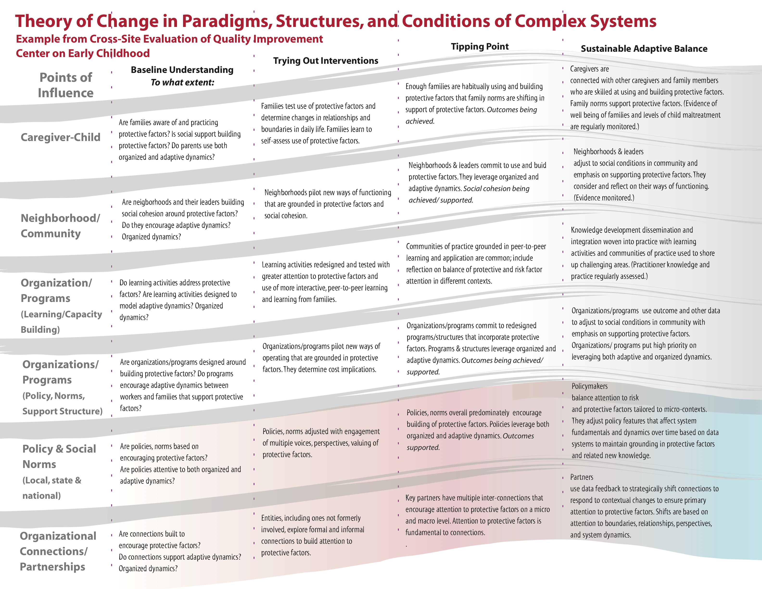

Simple rules are ways of behaving that can be applied to action in multiple settings. They are not necessarily easy to follow. They can also be thought of as guiding principles for action.

